John Kelly | Zach Rump  
16615329 | 12337948

Prelab 03.

1. In 7 segment LED,
   1. how are the 4 bits programmed,

In order to program the four bits, you must enable the control signal to low. A high signal turns off the LED.

* 1. how do they time multiplex.

“The LED control signals are time-multiplexed to display data on all four characters, as shown in Figure 3-2. Present the value to be displayed on the segment control inputs and select the specified character by driving the associated anode control signal Low. Through persistence of vision, the human brain perceives that all four characters appear simultaneously, similar to the way the brain perceives a TV display.” (17).

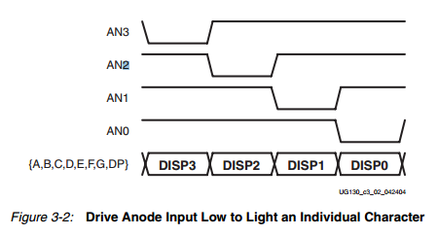

Essentially, it is demultiplexing a signal so that each on alternates receiving a low (enable) signal. This doesn’t happen simultaneously, but we see it that way.

* 1. What is the scanning technique?

“The scanning technique reduces the number of I/O pins required for the four characters. If an FPGA pin were dedicated for each individual segment, then 32 pins are required to drive four t-segment LED characters.”

* 1. What is the advantage and disadvantage of scanning?

“The scanning technique reduces the required I/O down to 12 pins. The drawback is that the FPGA logic must continuously scan data out to the displays.“ (17).

1. ii. Open the ucf file, which is uploaded to the lab. Check if all the pin connections are programmed correctly. Report if there is any change required. ‘LOC’ is the IO pin number to the FPGA.  
     
   NET "Ci" LOC = "M13" ; -> M13 is for a button 0 , Ci should be M16.